**Ian Doherty X00103407**

**Gavin Hickey X00109563**

The idea of making a video game is a shared passion from both of us and so it makes sense for both of us to create a video game. We decide that by choosing a video game to develop would be interesting for the both of us making it less of a chore and more of something we look forward to making, this helps build a good work ethic.

In this section we will be going over:

* Project Background
* The Project Aim
* Our Project Objectives
* And Our Project Output

Project Idea 1

A side scrolling old school shooter video game.

**Project Background**

The game is inspired by the old Sega Mega Drive classic Contra and many other side scrolling shooters.

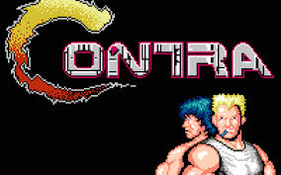Contra was a side scrolling run and gun arcade game released in 1987 and developed and published by Konami. Most of its popularity at the time of release was due to the two player co-op mode, a rarity at the time.

The game spawned many sequels and is still popular among old school arcade fans to this day.

We have chosen to make a game inspired by contra due to its popularity and how it has made a staple of many other popular arcade games to this day.

**Project Research**  
By researching games like Contra and other side scrolling arcade titles we can help better understand what made these games great and so popular and by using this information we will create our game to match these qualities and come up with ideas.

We will also learn new skills during our research such as video game design, testing and public interaction in order to get better feedback from possible future players and of course learning to work as part of a team.

By researching we will also learn new coding methods and styles in order to develop our video game. We will find new ways of implementing these coding methods into our game and also learn how to style the game itself with new ways to design graphically. We will also be working on possible implementation of the co-op system making it possible to play this game with another player through a LAN/WAN network.

**Project Aim**

Our aim for this Project is to create a fully functional side scrolling shooter video game with co-op functionality as well. We aim to learn new coding methods and implement them into the final project and create a game that has elements from other video game titles that we have studied and learnt from. We aim to have other people test our game and so to prove it is playable from the general public. We aim to create a fun and functional arcade title of our own.

**Project Objectives**

**Research and Analysis**

We will being researching many aspects of video game development in order to create our project. Will be looking up the different side scrolling video games available and learning from these what made them great and popular, coming up with new ideas to make our video game a combination of these traits in order to get the best out of our project.

**Case Study Analysis**

We will be carrying out a case study to learn more about these games and how they are developed in and more in depth and detailed way.

**Prototype Creation**

We will be making different prototypes of the game itself in order to test and develop it over time learning from them in order to develop the final project.

**Recommendation**

We will be researching different video games and seeing which is more recommended by the industry and public in order to find the most popular games and use those to help come up with ideas for our final project.

**Bug Testing & Game Testers**

We will also be asking for help from the public in the form of game testers. Along with ourselves will be using the help of these testers to help find errors in our video game. Tis way we can have several different players testing the game functionality and whether something is not working so that we can find these errors and correct them in and much more productive manner.

**Music Research**

We aim to add music track to the video game in order to make the game more enjoyable to play and also to learn and develop our skill. We will be researching different sound tracks from arcade video games that suit our project and learning how these are created so that we can make our own for our final project.

**Multiplayer Aspects**

A big development objective will be the inclusion of a small co-op multiplayer system. We will be researching how this is done and will be developing a co-op system through a LAN/WAN network. We aim to have two player able to play with each other through a network.

**Project Output**

The project output will be a well research and developed, tested, side scrolling shooter arcade game with multiplayer functionality.

Project Idea 2

A top down two dimension turn based role-player game.

**Project Background**

This idea is in spired by Nintendo’s Pokémon series of games. This is the second most successful game series ever spawning 15 different iterations and many spinoffs even though the formula has stayed the same throughout all sequels.

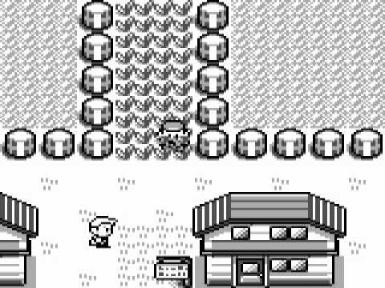

There are many other games like this and it is a very successful market this is just the most popular one of many.

**Project Research**

In the research portion of the project we will not only research and use other successful games of this type as templates we will also use the gaming community which would be our target users for their input into what they would like to see in the game when it is a finished product.

We will develop our ability to work as part of a team even more since the 2nd year project. We will have to make important choices that will affect the project such as coding language and which idea to go ahead with.

If we go with a new language to do this project we could be learning extra skills that we would before not have had a chance to use therefore improving ourselves along the way. We will have to learn graphical skills for this project in order to make the video game.

For this idea we will also have to learn how to implement a save system for the players characters for continual progression in the game.

**Project Aim**

The aim of this project is to learn new skills on our own and to progress our knowledge of our current skills. We aim to take all the user suggestions and features from currently released games then implement them into a fully developed functional top down role playing game.

**Project Objectives**

**Research and Analysis**

We will be researching a wide variety of top down role playing games and using the best parts of them and then adding features in we have not seen that we would llike in the game.

**Case Study Analysis**

We will research open case studies and developer diaries of current games to better understand the development process of games in the real world.

**Prototype Creation**

We will be making this game through many prototypes to get the basics working and with each iteration of it having more features and improvements on old features than the last until we have our full game ready for release.

**Recommendation**

We will be getting user surveys out into the gaming community for their input into what they would like to see in the project so we can not only make this for us but for a wider range of people.

**Bug Testing & Game Testers**

We will be constantly testing our code from the time of our first prototype to find all bugs in the code. We will also get the help of the people we know to test for us so that we will get more play types than just our own which we will be coding for.

**Music Research**

We have decided to add sound and music tracks to the game as a way of improving the experience of the players. By doing this will have to try find soundtracks with no copyright which will give us an idea of the legal procedures of game development.

**Game Saves Mechanics**

We have decided to make it possible to have up to 3 characters saved on the game. This will be a new mechanic for us to try to develop and a little extra challenge for us as developers.

**Project Output**

The project output will be a well research and developed, tested, top down role playing game with multiple save slot functionality.